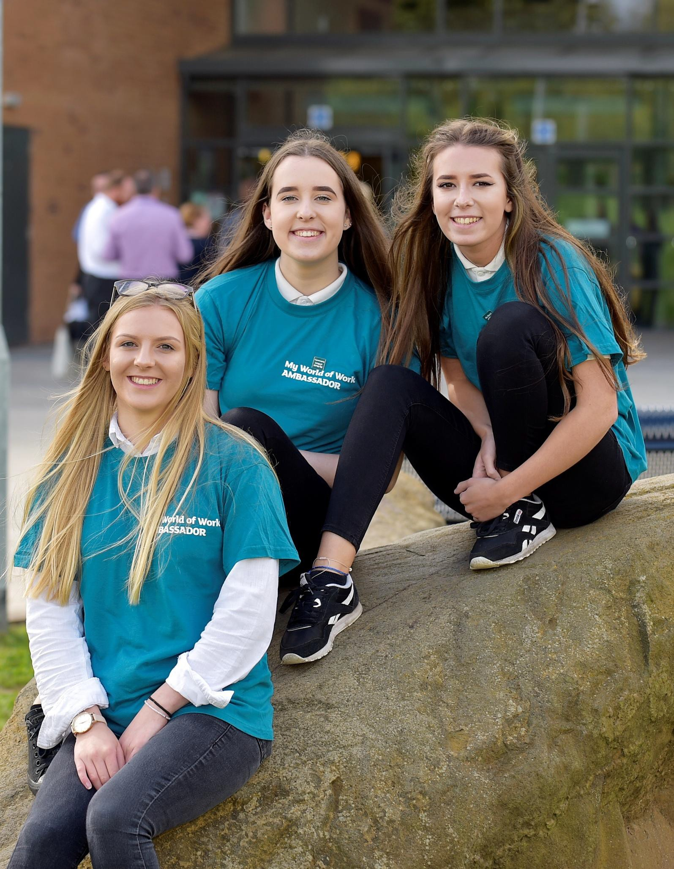

My World of Work Ambassadors: Schools
Planning, delivery & reflection
Build your career management skills and employability by promoting My World of Work to others

This template has been created to help our My World of Work School Ambassadors to plan, deliver and reflect on events and activities they are planning and delivering.

The template can be used to identify and record:

- when and where it’s happening

- who your event/activity is for and what do you want them to learn

- what you need to do to prepare

- what equipment you will need

- what marketing materials/resources you might need to order/create

- identify possible risks, issues or challenges

- roles and responsibilities

- what went well and what might you change or do differently next time

Planning – Where and When

What is the date of the event?
Where is the event taking place?
How many attendees are you expecting?
Does the venue have WiFi or mobile signal?

Planning – The Audience

Who is the audience?
What do you know about them?
What aspects of My World of Work might they be interested in?
What do you want them to do?
What do they want them to learn?

Planning – Preparation

What will the team need to do in preparation for the event?
Who do you need to speak to, to help your preparation?

Planning – Equipment

What ICT equipment will you need?

Planning – Marketing resources/materials

What marketing materials will you need?
Who do you need to speak to/ contact to get these materials?
What resources/materials will you need to create for the event (e.g powerpoint/poster etc)?

Planning – risks/issues/challenges

What risks, issues, challenges do you anticipate?
What can you do to overcome or minimise these risks, issues or challenges?

Roles and responsibilities

Who is leading the team for this event?
What other roles are required and who’s leading on these? | Role | Name(s)

Reflection

What went well at the event?
What would you do differently?
What skills did the team develop?

