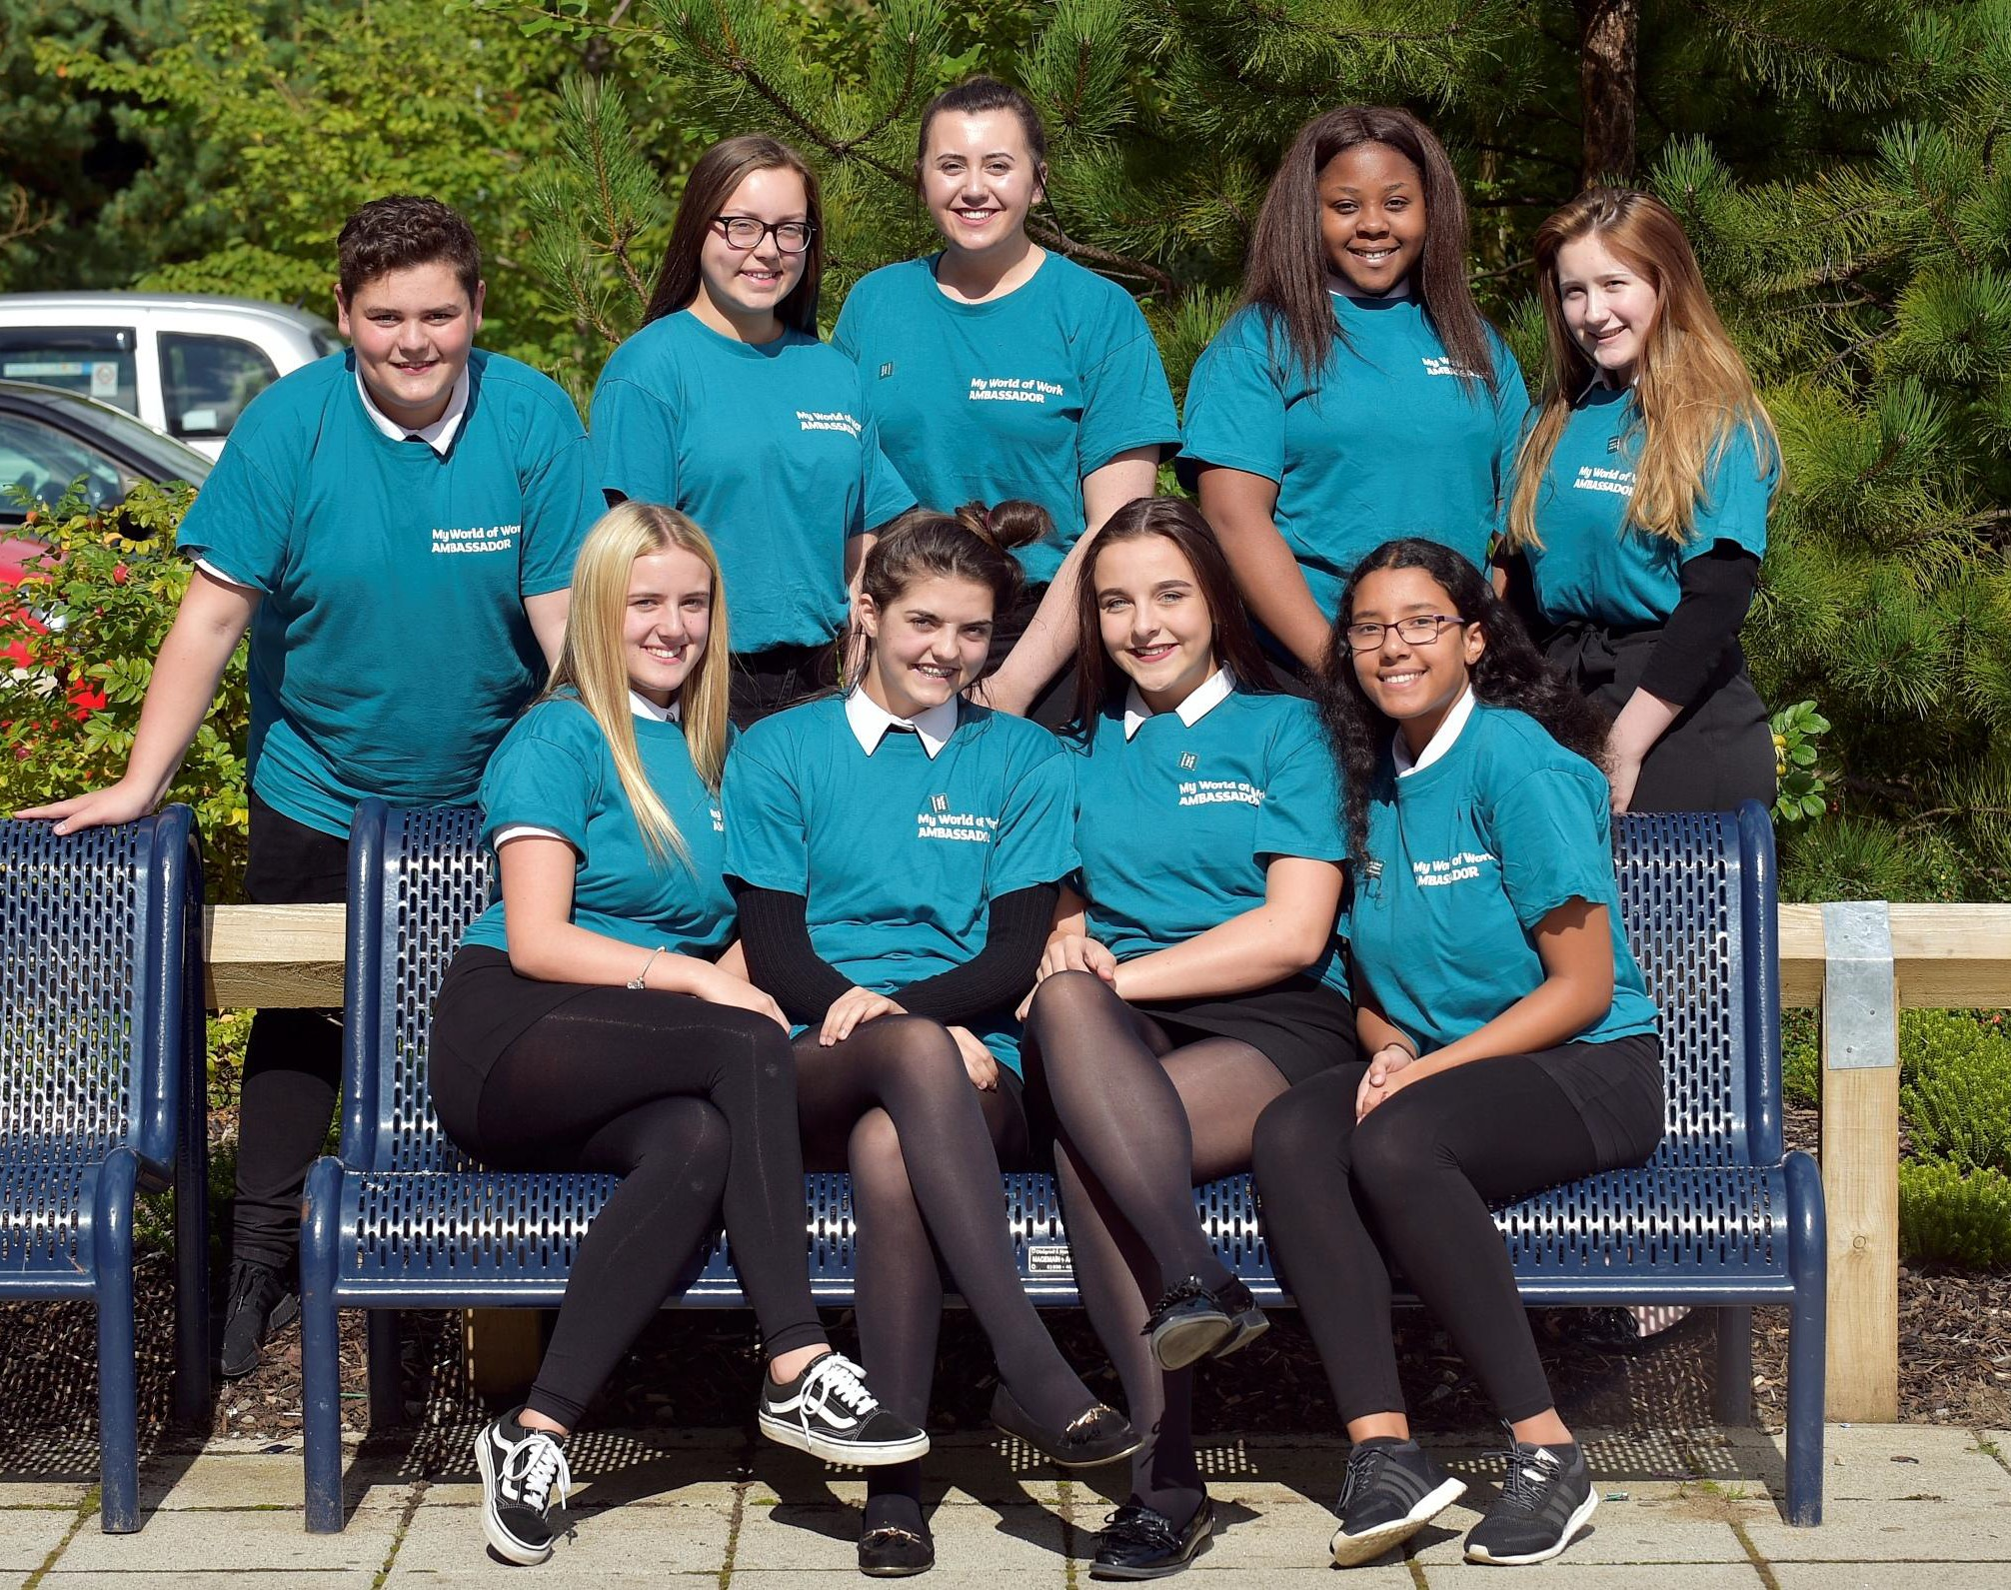

My World of Work Ambassadors: Schools
End of Term
Build your career management skills and employability by promoting My World of Work to others

This template has been created to help our My World of Work School Ambassadors to capture and feedback what they have been doing in the previous few months and what impact this has had on themselves and the rest of the school.

The template can be used to identify and record:

- events and activities that you’ve organised and run

- who attended

- what you did

- what impact you think the event might have had

- how you have personally benefited as Ambassadors

- what advice would you give other/new school Ambassadors

Event/Activity 1

What was the event/activity? |  | Date of event
Who were the main audience?
How many people attended?
What did you do at the event?
What did you enjoy most about the event?
What skills did the team develop?
What advice would you give to other Ambassadors thinking of running a similar event?

Template Record
What did you enjoy most about the event?

What skills did the team develop?

What advice would you give to other Ambassadors thinking of running a similar event?

Event/Activity 2
What was the event/activity?

Who were the main audience?
How many people attended? What did you do at the event?
Date of event

What was the event/activity? |  | Date of event
Who were the main audience?
How many people attended?
What did you do at the event?
What did you enjoy most about the event?
What skills did the team develop?
What advice would you give to other Ambassadors thinking of running a similar event?

Event/Activity 3

What was the event/activity? |  | Date of event
Who were the main audience?
How many people attended?
What did you do at the event?
What did you enjoy most about the event?
What skills did the team develop?
What advice would you give to other Ambassadors thinking of running a similar event?

Event/Activity 4

What was the event/activity? |  | Date of event
Who were the main audience?
How many people attended?
What did you do at the event?
What did you enjoy most about the event?
What skills did the team develop?
What advice would you give to other Ambassadors thinking of running a similar event?

Event/Activity 5

What was the event/activity? |  | Date of event
Who were the main audience?
How many people attended?
What did you do at the event?
What did you enjoy most about the event?
What skills did the team develop?
What advice would you give to other Ambassadors thinking of running a similar event?

Event/Activity 6

What was the event/activity? |  | Date of event
Who were the main audience?
How many people attended?
What did you do at the event?
What did you enjoy most about the event?
What skills did the team develop?
What advice would you give to other Ambassadors thinking of running a similar event?

