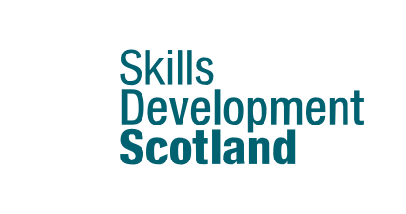

My World of Work Ambassadors: Schools
Self Assessment

Build your career management skills and employability by promoting My World of Work to others

This template has been created to help our My World of Work School Ambassadors to capture information about themselves both before starting the programme and at the end of their Ambassadorial role.

The template can be used to identify and record:

- why you volunteered to become an Ambassador

- what you bring to the team

- what skills you want to develop

- your confidence in yourself about your skills and strengths both before and after participating

I volunteered to be a My World of Work Ambassador because...

First Name/Last Name What I bring to the project team
*Add a profile photo here

About Me | Ambition
1.

2.

3.
Interests | Strengths
Skills | Skills I want to develop

Take time to familiarise yourself with the My World of Work content on skills:

- My career options: What are my skills?
- Career expert: How your transferable skills can help you make your next steps
- Article: What are career management skills and how can they help you?

How would you rate your confidence level with the following: | BEFORE starting on the programme |  |  |  |  | AFTER participating on the programme
Ambassador role | Low |  |  |  | High | Low |  |  |  | High
Using My World of Work to support your own career management skills? | 1 | 2 | 3 | 4 | 5 | 1 | 2 | 3 | 4 | 5
Showing others how to use My World of Work? | 1 | 2 | 3 | 4 | 5 | 1 | 2 | 3 | 4 | 5
Key Ambassador skills | Low |  |  |  | High | Low |  |  |  | High
Finding solutions to problems | 1 | 2 | 3 | 4 | 5 | 1 | 2 | 3 | 4 | 5
Taking the lead | 1 | 2 | 3 | 4 | 5 | 1 | 2 | 3 | 4 | 5
Planning and organising | 1 | 2 | 3 | 4 | 5 | 1 | 2 | 3 | 4 | 5
Working as part of a team | 1 | 2 | 3 | 4 | 5 | 1 | 2 | 3 | 4 | 5
Communicating with people | 1 | 2 | 3 | 4 | 5 | 1 | 2 | 3 | 4 | 5

Career management skills review:

- Refresh your knowledge of the article: Career management skills and how they can help you

What career management skills have you developed as part of the ambassador project?

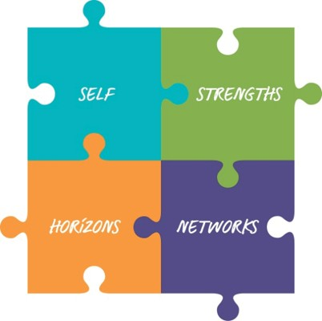What have you learned about your Self? How have you developed your Strengths?

What Horizons have you explored? What Networks have you developed?

